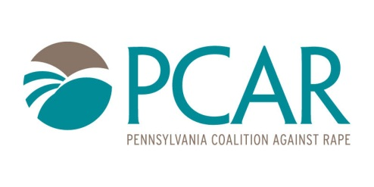
Adam Kulikowski
Communications Director, PCAR
717-728-9740 ext. 154
akulikowski@pcar.org

September 5, 2019

FOR IMMEDIATE RELEASE:

At-home rape kits leave victims without services and pathways to justice
HARRISBURG—The Pennsylvania Coalition Against Rape does not support the use of at-home rape kits following a sexual assault.
After an assault, it is important survivors consider seeking medical attention and understand the potential risks associated with the use of at-home kits.
Specially trained health care providers at hospitals across the Commonwealth are prepared to examine victims following an assault and care for their immediate safety. They conduct a forensic exam at no cost to the survivor, collect evidence, and screen for and treat sexually transmitted infections and other possible injuries. Those who would use at-home kits would also forgo the on-site assistance of a rape crisis center counselor. Counselors provide support during the forensic exam and long-after. They are confidential, trained professionals who help the survivor understand their legal options and support them in navigating their healing process.
An at-home rape kit cannot prevent pregnancy, identify or treat potential physical and mental health issues. It is highly unlikely the at-home kit collection would align with Pennsylvania’s legal requirements. This would jeopardize the victim’s ability to see the evidence used in criminal proceedings to hold the offender accountable.
The Sexual Assault Testing and Evidence Collection Act dictates the specific requirements associated with sexual assault evidence collection and testing in Pennsylvania. It is critical that evidence be collected, tested, and preserved in compliance with this Act. At-home kits would not comply with current law. According to this Act, evidence must follow the chain of custody and be picked up by law enforcement from health care facilities within 72 hours of being collected through the forensic exam. Law enforcement must submit evidence to approved laboratories within 15 days, with the victim’s consent. Labs must test kits received by law enforcement with jurisdiction over the crime. Such laboratories are approved by the Department of Health.
It is highly unlikely that at-home evidence would be admissible to labs or courts of law throughout the Commonwealth—doing a great injustice to victims and survivors of sexual harassment, abuse, and assault.
For these reasons, PCAR does not support at-home rape kits. We strongly caution against this product, which is clearly not aligned with best practices or pathways to justice and safety for the Commonwealth.
For more information on the services available to victims after a sexual assault, visit www.pcar.org or call your local rape crisis center.
-END-
About PCAR:
PCAR works to end sexual violence and advocates for the rights and needs of sexual assault victims. We partner with a network of rape crisis centers to bring help, hope, and healing to people in all of the Commonwealth’s 67 counties. Last year, rape crisis centers provided services to approximately 30,000 victims. Each year, rape crisis centers teach over 300,000 Pennsylvanians how to stop sexual violence in their communities. Over 50,000 professionals are trained by rape crisis centers to enhance the Commonwealth’s systemic responses to victims.

